AWQ 3OI Photo Challenges - Exercise Evaluation
For this assignment, you will be asked to complete a series of photo challenges. These photo challenges will ask you to employ new skills and techniques that we learn in class, and get you to experiment with photography outside of class time as well. There will be a number of challenges that you can complete. At the end, you will be asked to assess your own images and choose 3-5 that you feel are your most successful. These 3-5 images will be submissions for a class critique and final grade.

Checklist
□ | Minimum of 3-5 Exercises Complete |  | Comments
 | - Deconstructed Landscapes  - Hidden Messages  - Humans of FHCI  - Ugly Background  - Creative Flash  - Light Painting  - Ghost Image | - Parking Lot Abstracts  - Bokeh  - Oil Abstracts  - Multiple Exposures  - Optical Illusions  - Camera Hacks  - Intentional Camera Movements  - Flashlight effects (strainer, rainbow CD, prism, etc.)
□ | - Show an understanding of essential design skills  - Display knowledge of camera settings and editing tools

 | Design Skills |  | Technical Skills
□ | - Use the principles and elements of design to create effective compositions  - Explore additional “rules,” such as the rule of thirds, when composing images | □ | - Use camera functions (shutter speed, aperture, ISO, white balance) at will to manipulate image outcome  - Use camera equipment properly and responsibly where needed (tripod, lighting, props, etc.)
□ | - Experiment with different camera angles and viewpoints | □ | - Apply Photoshop filters, adjustments, and tools where needed to help enhance and compose images
□ | - Use images and composition to effectively communicate messages visually and artistically | □ | - Export & save at a proper resolution  - Final images are print & web ready
□ | - Be able to self-assess, identify, and reflect on which images successfully use composition and design elements | □ | - Use editing apps to enhance and adjust images shot with phone cameras

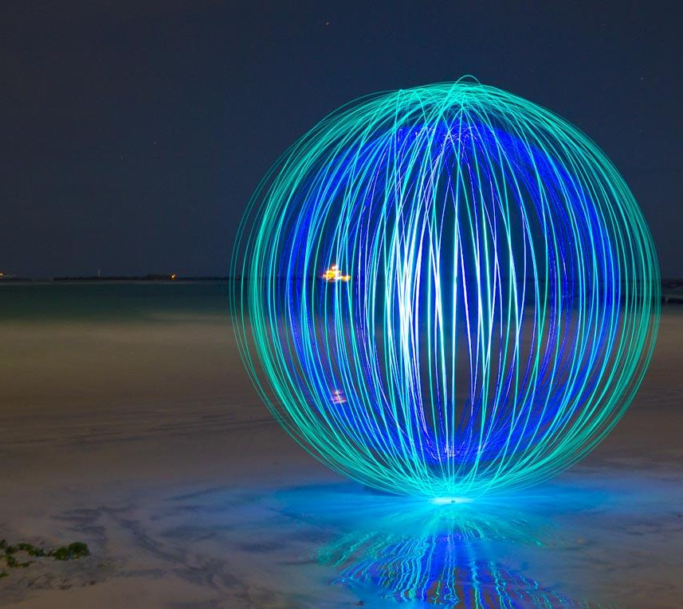 | 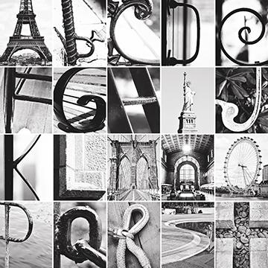 | 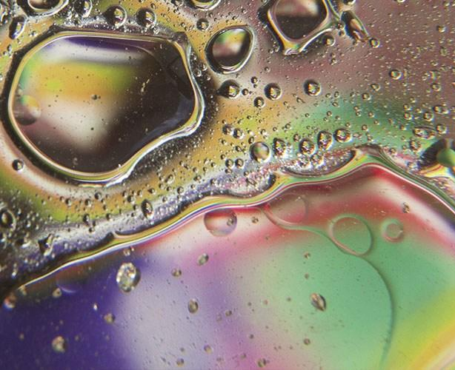

Photo Challenge Evaluation
Description | Comments | Levels
Studio Work - Application of Skills
The elements and principles have been effectively used in the composition of your images. |  | 0-1-2-3-4
Camera techniques and equipment have been used to explore lighting, camera functions, & angles. |  | 0-1-2-3-4
The photos have been properly edited to enhance the overall appearance and composition. |  | 0-1-2-3-4
Each of the photos are in-focus and display proper exposure (lighting). |  | 0-1-2-3-4
The final presentation of your images displays a strong compositional sense, and an effective overall appearance. |  | 0-1-2-3-4
Exploration | Experimentation | Effort – Sharing Work & Ideas (Critical Analysis)
Planning & Process  Photos show evidence of experimentation and exploration of photo techniques and processes. It is clear that multiple photos were taken in order to arrive at the final product.  Each challenge demonstrates a creative approach to the techniques of the challenge in order to produce something original and unique to the student’s style. |  | 0-1-2-3-4  0-1-2-3-4
Critical Analysis  The 3-5 photos chosen display a strong sense of artistic awareness about effective design and technical skills.  Sharing of the work provides insight into the creative process, as well as displays strength in ideas, techniques and an interest in continual refinement of skills.  - What did you do well?  - What challenges did you encounter?  - Where did you find inspiration?  During the critique, student was able to effectively analyze and communicate thoughts about others’ images to provide helpful feedback. |  | 0-1-2-3-4  0-1-2-3-4  0-1-2-3-4
Overall Mark |  | %

