Graphic Novel / Editorial
_________________________________________________________________________________________

General Guidelines
1. For this assignment you will take a series of photos to create one of the following two options:
A) Write and photograph your own Graphic Novel
B) Write and photograph your own Editorial
________________________________________________________________________________

Option 1: Graphic Novel

1. For this option you will submit a 5-10 page comic/graphic novel that uses a comic book layout style.
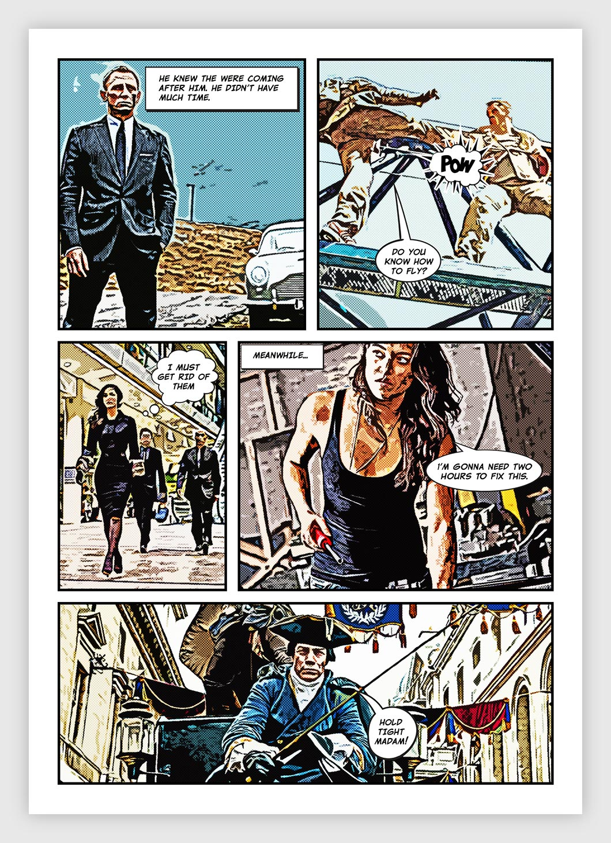
2. You will also design a book cover in addition to the 5-10 pages of your story.

3. A) Your story must include a hero, plot, action, events, and a theme.
B) Topics or themes may include the following:
▪ A superhero trying to save the world
▪ A love story
▪ Solving a crime
▪ Exploring a haunted house

This list is a guideline to help you get started--you are not limited to these ideas.

4. As part of your brainstorming, you might want to create thumbnail storyboards that outline picture ideas and key areas of dialogue and descriptions. This is not necessary but may help you if you’re having trouble thinking of ideas or trying to decide what angles and shots you will want to use.

5. Edit your pictures using Photoshop and filters to create the illusion of a graphic/comic book look.

6. Your final project will be evaluated in the following areas:
▪ Page layout and composition (how your panels flow together and create visual interest)
▪ Variety of angles and shots used in the panels
▪ Overall flow of the graphic style used throughout the story
▪ Placement of text/ dialogue with images
▪ How well the pictures and story work together to create interest for the reader
▪ Cover design (how the cover lets the reader know what the story will be about, visual interest and composition)

Tips:  1. The Artistic filters allow you to create painted effects such as watercolour, poster edges, and Smudge Stick.  2. Lighting effects  >Filter >Render >Lighting Effects  Note: You can change the number of lights and the colour of your light(s). | 3. Use various Blending Modes  >Duplicate your photograph  >Create a Sketch filter on the top layer such as Graphic Pen  >Set the Graphic Pen layer to Multiply and you merge the effect with the photo (like assignment #1). | 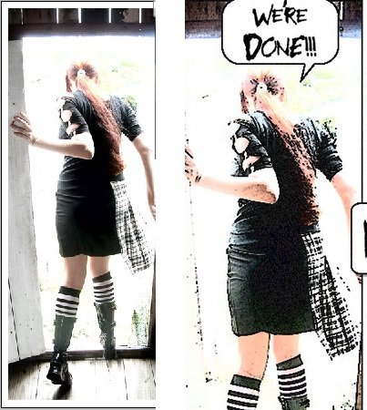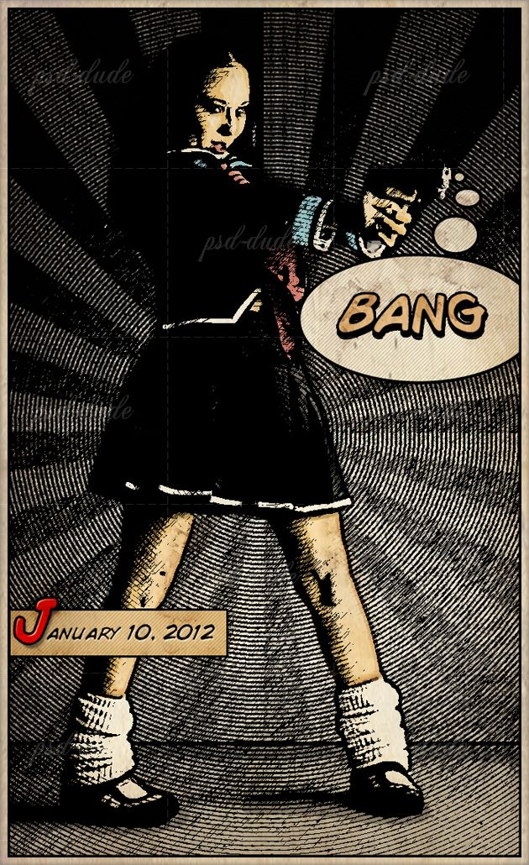

Option 2: Editorial

1. For this option you will submit a 5-10 page editorial story in the form of spreads that uses a magazine layout.

2. You will also design a cover page for the article in addition to the 5-10 pages.
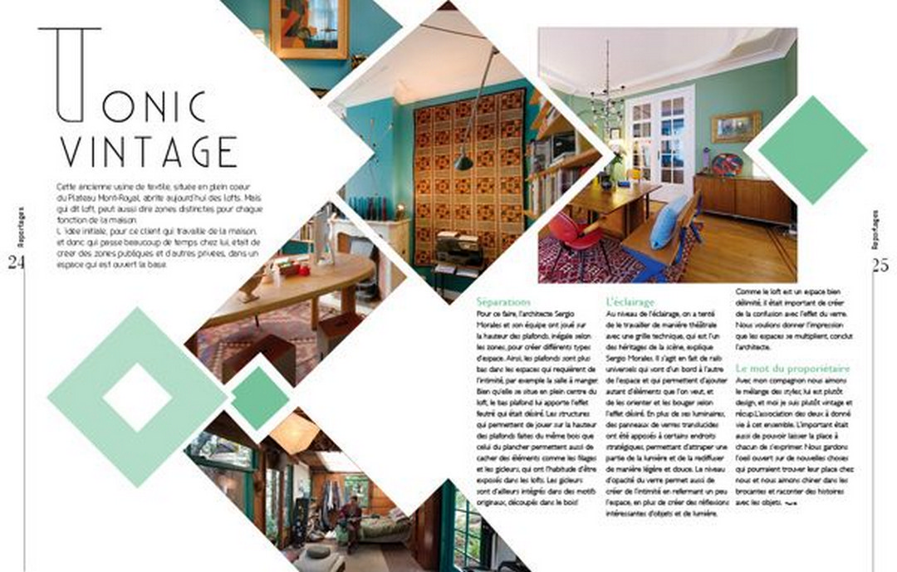
3. A) Your editorial must be on a topic of your choosing and should
explore information regarding this topic.
B) Topics may include the following:
▪ Skateboarding Tips and Tricks
▪ Fashion
▪ Interior Design
▪ Music/Concert Review
▪ An Interview

This list is a guideline to help you get started - you are not limited to these ideas.

5. As part of your brainstorming, you may wish to look through magazines to explore the different layouts used and articles written. You may also wish to draw out some thumbnail sketches that outline layout ideas. This is not necessary but it may help you when designing your final composition of your pages.

6. You will have to edit your photos and graphics to make sure that they all belong within the same article. For example, you may select a colour theme or filter that you want to stick with.

7. Your final project will be evaluated in the following areas:
▪ Page layout and composition (creates visual interest--would you want to read this editorial?)
▪ Variety of angles and shots used
▪ Overall flow of the article (is it easy to read and follow alongside your photos?)
▪ Placement of text with images
▪ How well the pictures and writing work together to create interest for the reader
▪ Cover design (how the cover lets the reader know what the article will be about, visual interest and composition)
▪ Research of information

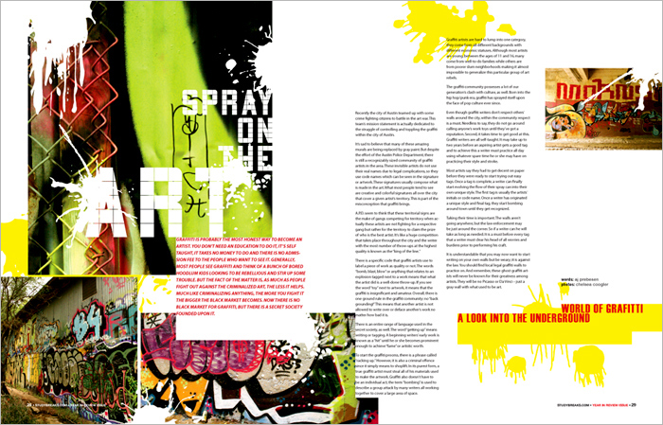 | 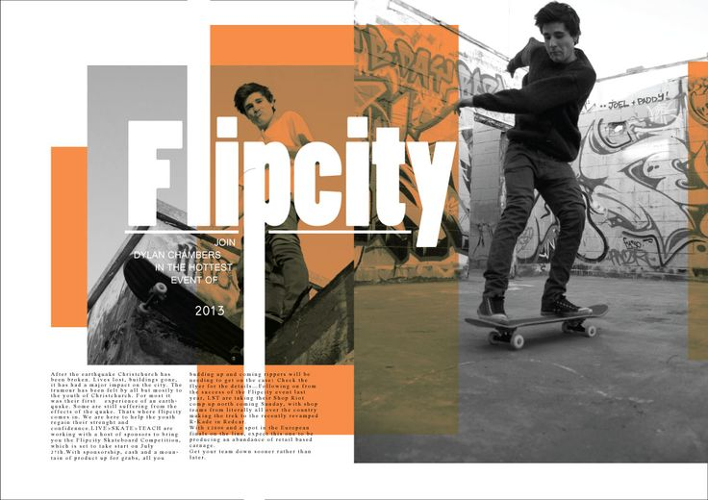

Graphic Novel/Editorial Evaluation

Description | Comments | Levels
Layout and Composition of Pictures - Exploration | Process

The layout of your graphic novel/editorial shows a strong sense of composition, using the principles and elements of design. It has been designed to be easy to read and look visually appealing. |  | 0-1-2-3-4
The photos show a strong range of angles and techniques. |  | 0-1-2-3-4
Each photograph displays an effective understanding of composition e.g. the rule of the thirds. |  | 0-1-2-3-4
Filters and Editing | Studio Work - Application of Skills

Your photos have been edited and enhanced in a manner that looks polished and fits the option you chose (graphic look for graphic novel, cohesive look for editorial). |  | 0-1-2-3-4
The pages have been edited to look like they belong together. |  | 0-1-2-3-4
Magazine/Comic - Text | Studio Work - Application of Skills

The captions/dialogue provided suit the images they are meant to go with and accurately describe what is happening. |  | 0-1-2-3-4
The background and font choice of your design enhances the photographic images and relates to your topic. The placement of text and font choice is clear for the audience to read. |  | 0-1-2-3-4
Research
The editorial/graphic novel shows evidence of careful research in terms of the layout design and provided information. |  | 0-1-2-3-4
Overall Mark |  | %

