Self Portrait Collage
_______________________________________________________________________________

Guidelines

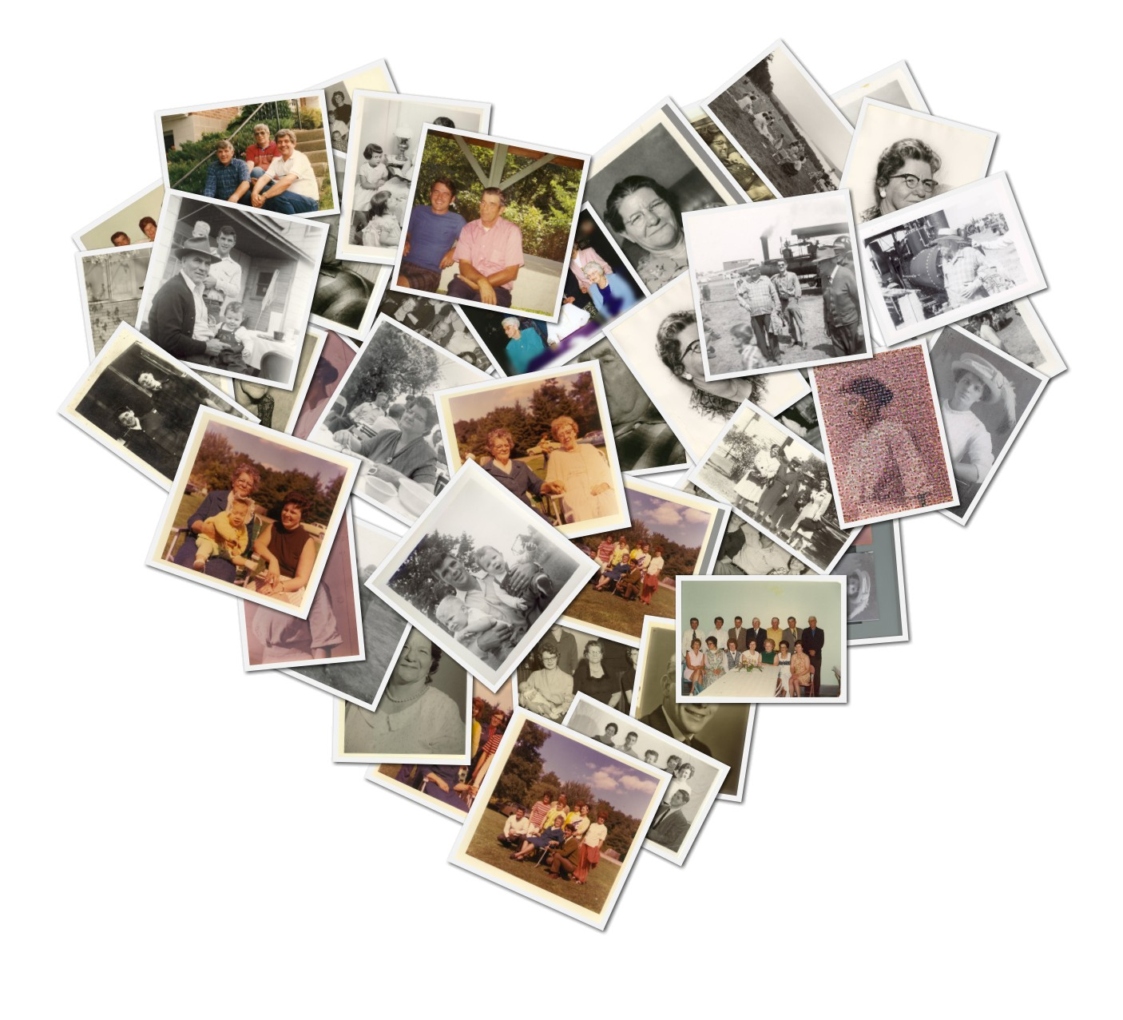
Minimum Pictures: 10

For your first assignment, you will create a photo collage that represents you and your interests. A photo of yourself must be somewhere in the collage. It can just be a selfie. The other photos must be images you take that represent who you are and your life. You can include any school appropriate images that you wish and that you feel represent you. Consider images that tell a little bit about your hobbies, ambitions, family, friends, work, school, etc. If you’d like, you can also include some photos you have taken in the past that you like and feel show your interests as a photographer, or you can take all new pictures.

All of the pictures should be your own and not taken off the internet. You can use your phone to take your pictures, and either email them to yourself or add them to your Google Drive in order to access them on a desktop computer.

In terms of software to assemble your collage, you may use anything that you are comfortable with. Some options include Microsoft Word, Google Docs, Google Drawings, BeFunky, Photoshop, etc. The shape, design, and layout of your collage is up to you, but each of your images should be visible. You are welcome to use templates you can find online, as well as text and symbols to accompany your images. These are the only parts of your collage that don’t have to be your own photos.

In addition to taking the pictures, you can edit your photos using the apps explored in class, or using ones of your own choosing. At this point, I am not going to be evaluating you on how well you take photos. I mainly want to see that you are experimenting with your photos and making an effort to give me a glimpse of who you are using the photo-taking process. I also want to see that you are taking the arrangement of your images into consideration.

Editing Apps Explored in Class

- Polarr
- Muglife
- Facetune
- VSCO
- Snapseed
- MRRMRR

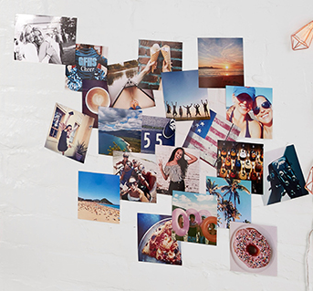 | 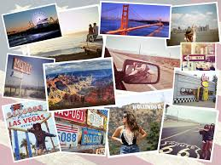 | 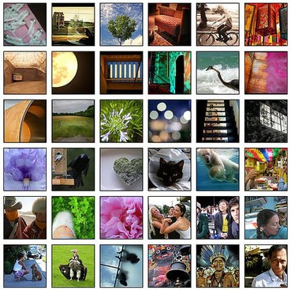
Self Portrait Evaluation

Description | Comments | Levels
Composition of Pictures - Exploration | Process

The photos show a strong range of exploration and experimentation. |  | 0-1-2-3-4
The photos chosen are related to the assignment and do a good job of illustrating who you are. |  | 0-1-2-3-4
The composition of your images is pleasing to the eye and arranged so that it each image is visible. |  | 0-1-2-3-4
Filters and Editing | Studio Work - Application of Skills

Your photos have been edited and enhanced in a manner that looks polished and professional. |  | 0-1-2-3-4
Overall Mark |  | %

