AWQ3OI: Digital Photography Style & Vision

Guidelines

- Create a series of still images (photographs, photo collages, photo design/ art) in the style of a photographer or photographic artist you find inspiring.
- You should create a minimum of 10 photographic images.

Research
- Research and create a presentation on a photographer(s) you find inspiring. It can be a famous photographer or an up and coming photographer from Instagram.
- Provide a minimum of 2 paragraphs written information about your photographer(s).
- Follow these 7 points while compiling your research and preparing your presentation

1. | Provide brief but important biographical information about the photographer.
2. | Outline the individual’s technical and artistic contributions to photography.
3. | a) Discuss the photographic style (lighting, mood, composition, camera angles…)  b) Explore reoccurring themes and or compositional elements in the work.
4. | Who or what influenced the photographer?
5. | a) What impact has the person had on other photographers?  b) Provide names and information about photographers or artists who have been inspired by your photographer.
6. | a) Provide at 10 examples of their photographic / artistic work.  b) You may also include an interview clip with the photographer.

Project Description

- Write a project description about your photos as part of your final project presentation.
  - The description should be 3-4 paragraphs in length (minimum).
- Clearly state your stylistic intentions.
- This description will explain the following:
  - Why you selected the particular director
  - Any decisions you made in interpreting the style
  - How mimicking the style and influence lead to your own personal vision or outcome
  - An explanation of content, subject matter, and message/ meaning

Photographer Resource List
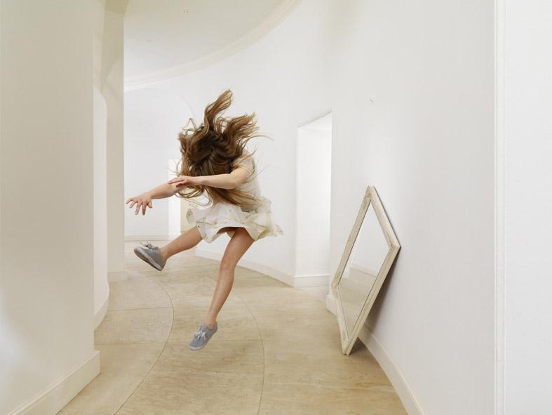
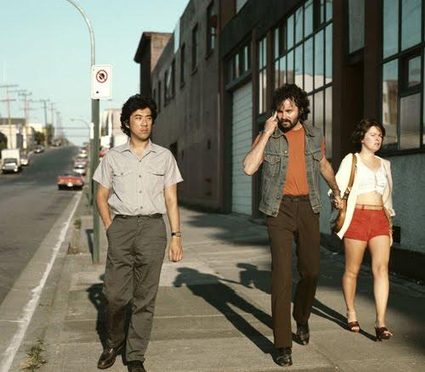

Cindy Sherman Jeff Wall Julia Fullerton

