Abstract Photography

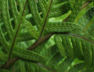 | 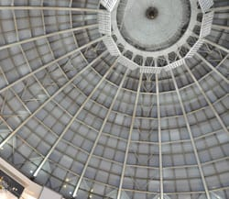 | 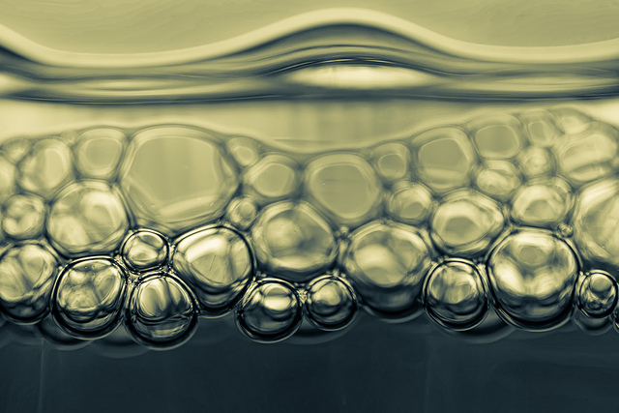 | 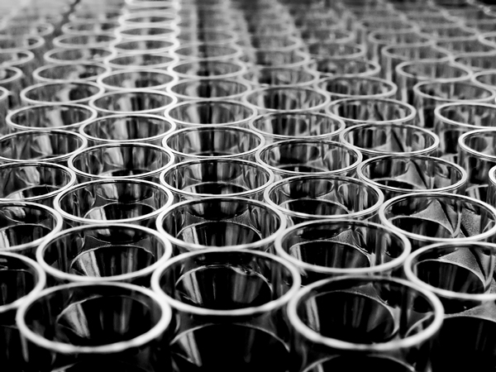

Guidelines

Total Pictures: 10

Abstract photography concentrates on line, shape, color, form, and texture. The viewer is often unable to see the whole object with the focus on only a small part of it. You can also see it as an image that does not have an immediate association with the object world.

Color – Submit 2 photos that show color as the main focus of the image. Colour consists of three properties: (1) hue or tint--the color name, e.g., red, yellow, blue, etc.: (2) saturation--the purity and strength of a color, e.g., bright red or dull red; and (3) value--the lightness or darkness of a color.

Line – Submit 2 photos that show at least one type of line. Vertical, horizontal, diagonal, straight or ruled, curved, bent, angular, thin, thick or wide, or interrupted (dotted, dashed, broken, etc.).

Shape – Submit 2 photos that have a shape as the main subject. Shapes are two-dimensional. Examples of shapes include: circle, oval, triangle, square, rectangle, etc

Form – Submit 2 photos that show a three-dimensional form. Forms are three-dimensional (height, width, and depth) and enclose a volume. For example, a triangle, which is two-dimensional, is a shape, but a pyramid is a form.

Texture – Submit 2 photos that display a good use of texture. Texture is the surface quality or "feel" of an object, its smoothness, roughness, softness, etc.

Notes
- The “Macro” setting (flower symbol) could be a helpful mode to use on the camera.
- Edit your photos on the computer as needed. Crop, rotate, change settings, etc.

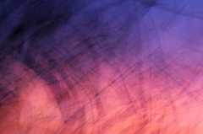  Colour | 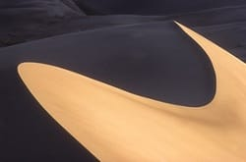  Line | 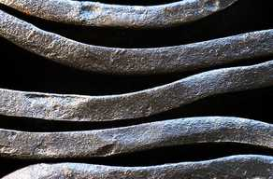  Texture | 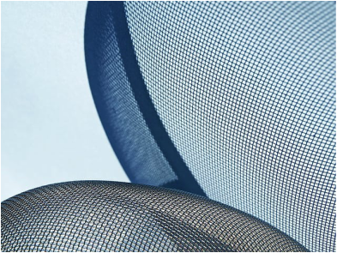  Form

Abstract Photography Evaluation

Description | Comments | Levels
Composition of Pictures - Exploration | Process

The photos show a strong range of perspectives and techniques (depth of field, correct exposure, etc.). |  | 0-1-2-3-4
Each photograph displays an effective understanding of composition e.g. the rule of the thirds, principles and elements of design, etc. |  | 0-1-2-3-4
Filters and Editing | Studio Work - Application of Skills

Your photos have been edited and enhanced in a manner that looks polished and professional |  | 0-1-2-3-4
Elements of Design | Studio Work - Application of Skills

2 pictures show a strong understanding of colour |  | 0-1-2-3-4
2 pictures show a strong understanding of line |  | 0-1-2-3-4
2 pictures show a strong understanding of shape |  | 0-1-2-3-4
2 pictures show a strong understanding of form |  | 0-1-2-3-4
2 pictures show a strong understanding of texture |  | 0-1-2-3-4
Overall Mark |  | %

