Photo Manipulation

Options  Master of Disguise  - Creature Feature  - Creative Panorama | Value Added Ideas to Explore  - Double Exposure Effect  - Combine an insect with another animal  - Combine a reptile with an amphibian

Master of Disguise - Guidelines

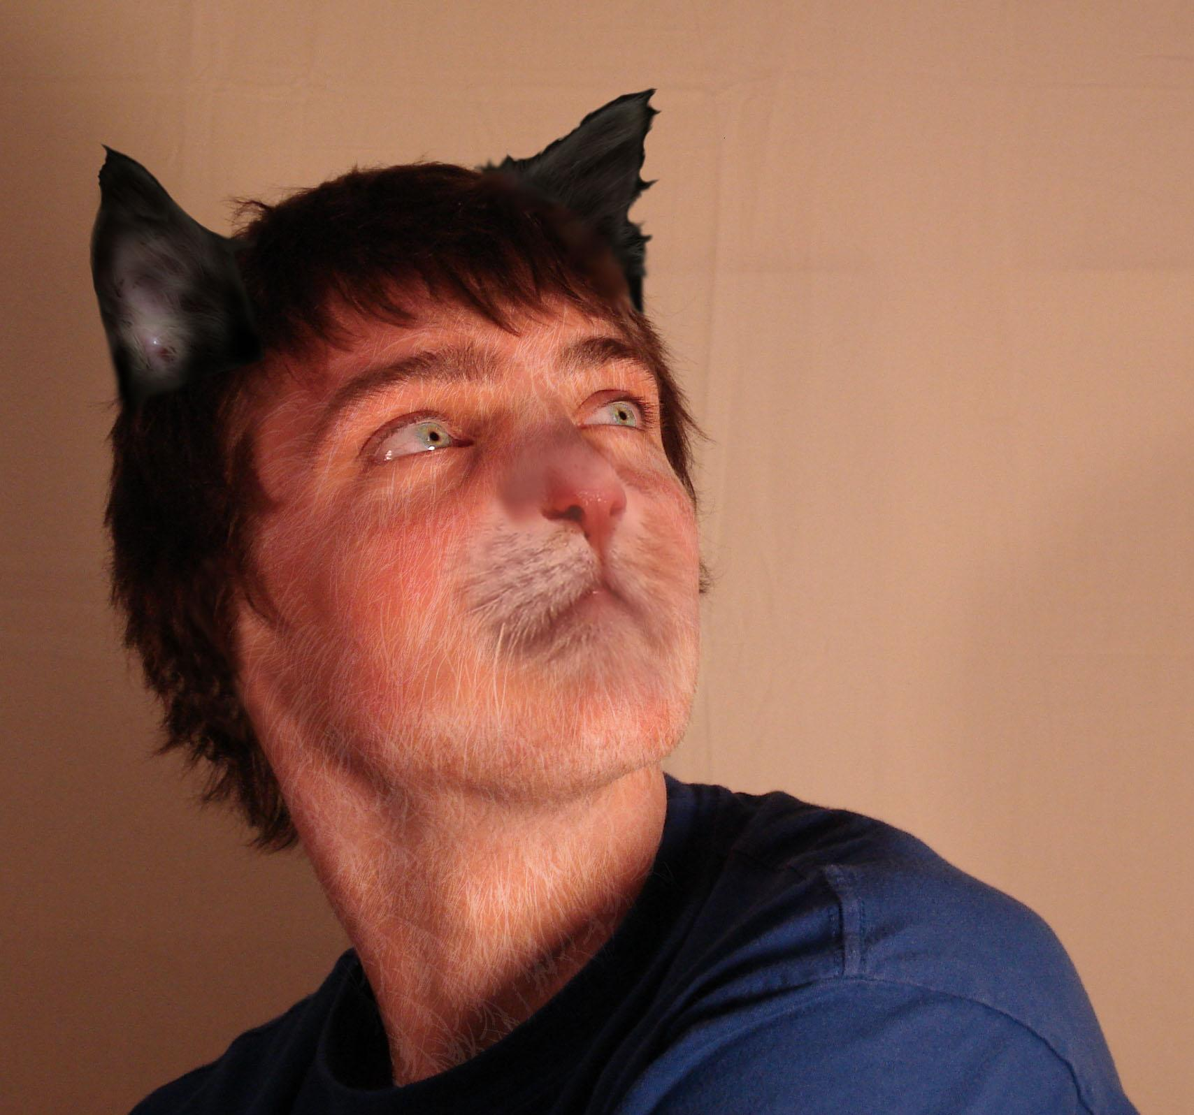 | 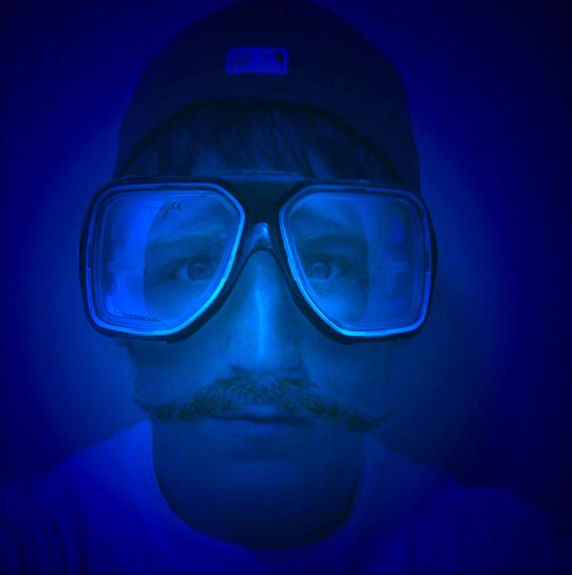 | 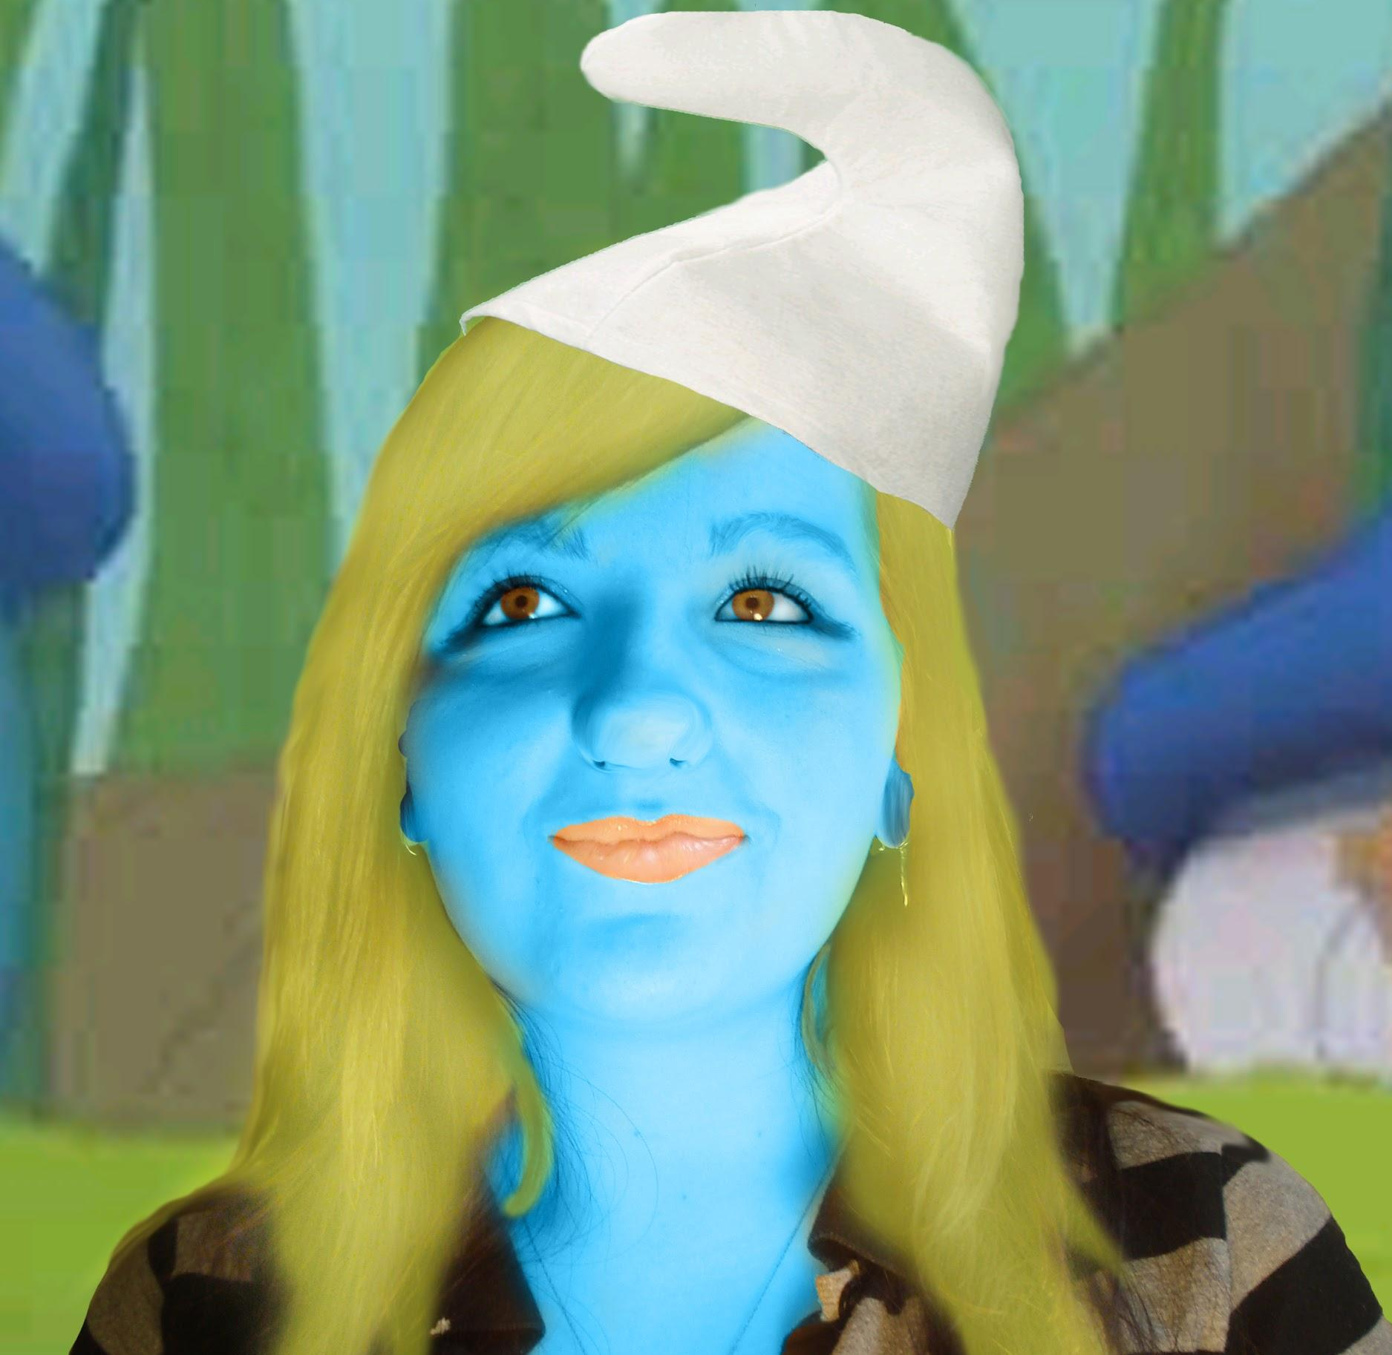 | 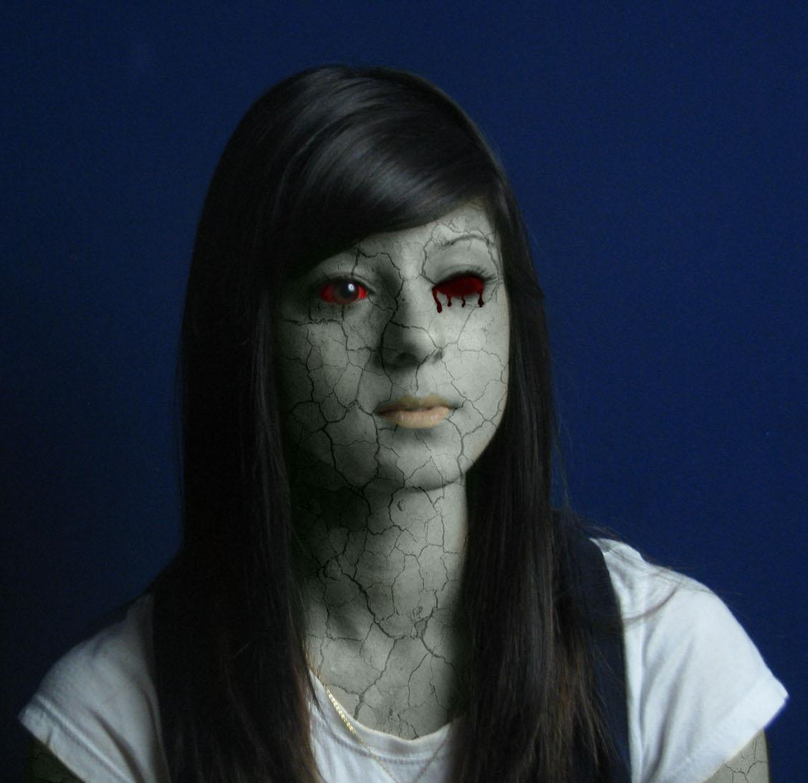

Part A: The Portrait

- By using a variety of lighting techniques discussed in-class, you will photograph a friend or classmate to create four portraits that explore how light can alter a face.  - Remember the 5 Common Portrait Lighting Styles: Butterfly Lighting, Split Lighting, Rembrandt Lighting, Broad lighting, Short Lighting  - Try hacking your cell phone flash by bouncing the light.  - Use a slow shutter speed and an off camera manual flash to create a multiple exposure effect. Use the coloured gels to add an extra element of creativity.  - One portrait must use a soft lighting technique that diffuses light. Another portrait should use strong shadows to create contrast and drama.  - When composing your photograph it is important that you consider the rule of thirds.  - You will submit these four portraits as part of your final project. | Hack Your Cell Phone  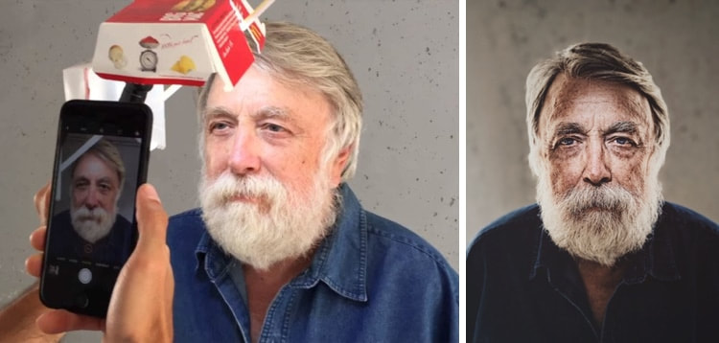  Photographer Philippe Echaroux used his Iphone, a flashlight, plastic straw and a Big Mac Box to create luxury lighting for his photo project.
Flash & Shutter Fun
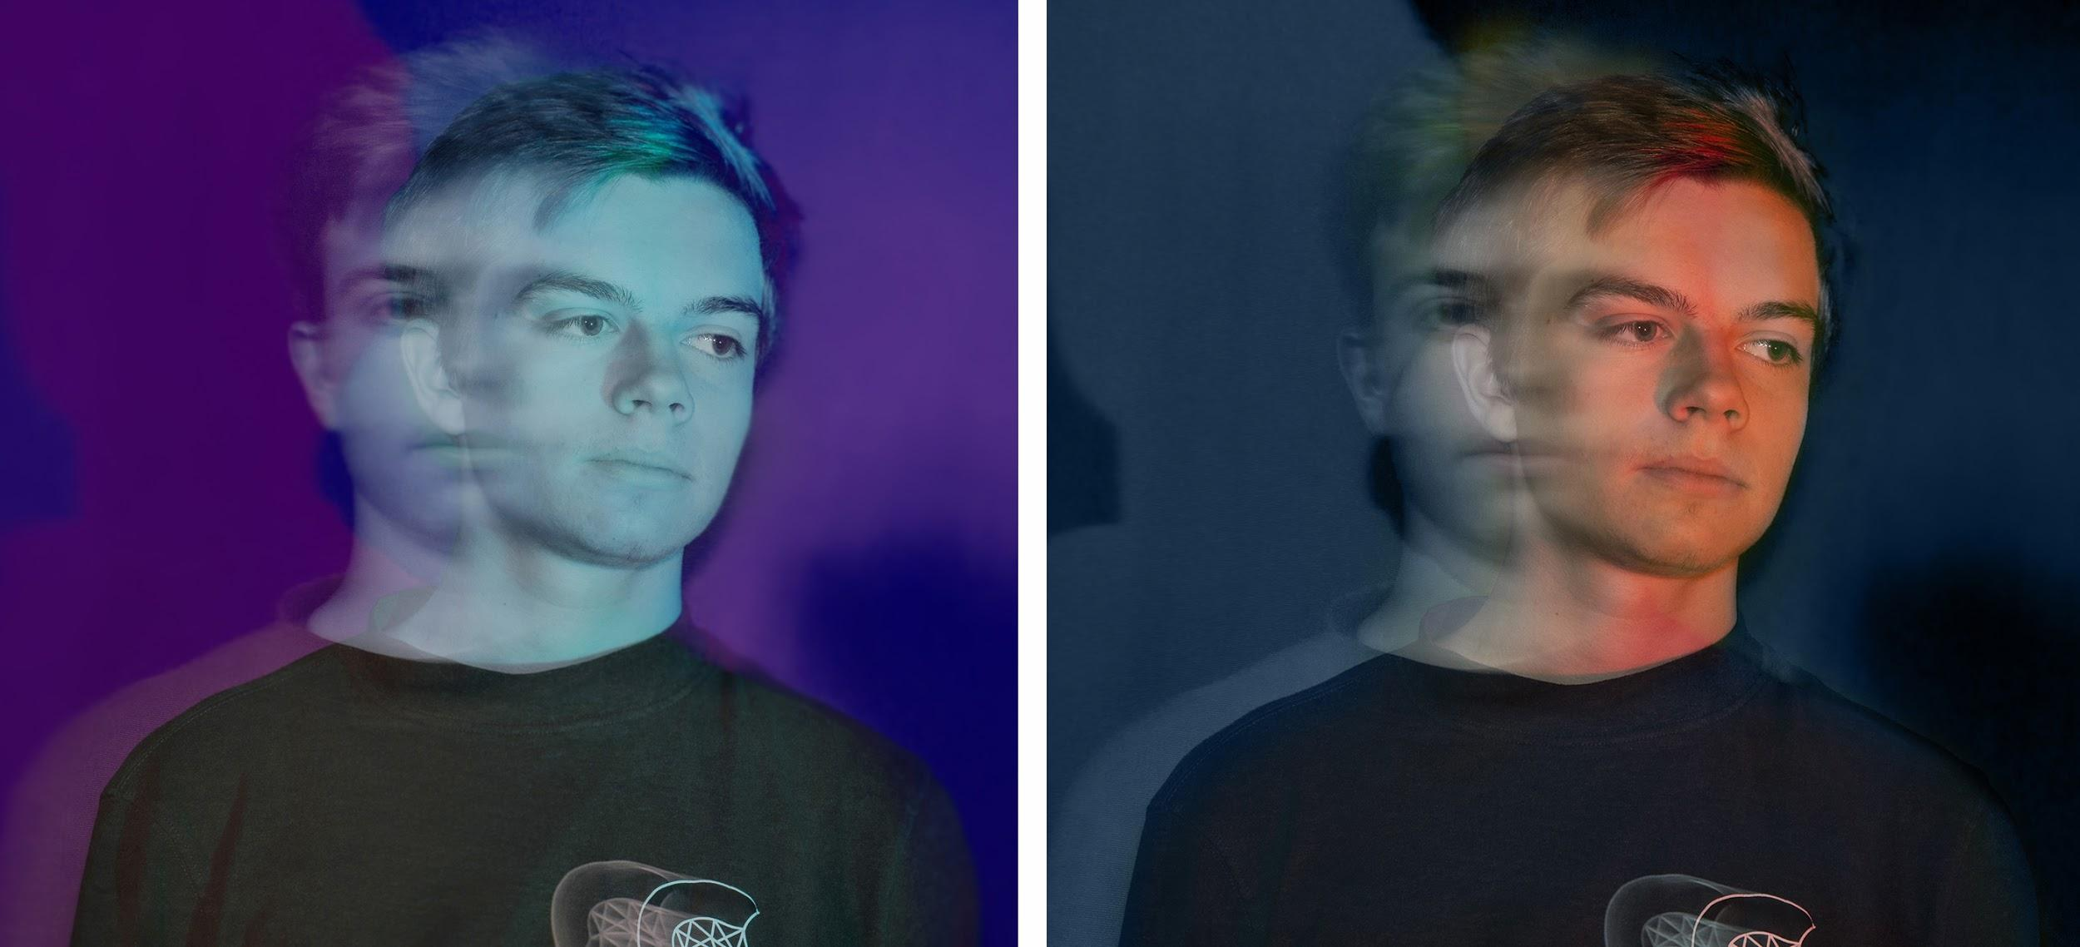
Slow Shutter Speed | Off Camera Flash with Colour Gels
Example Camera Settings: 6” | f19 | ISO 100
Variations: Photoshop - Adjustment Layers

Part B: The Disguise
- For this part of the assignment, you are to create three different images that use one of your portrait photos to create a series of facial transformations. In other words you will turn the person in your photo into a Master of Disguise.
- All three images must make the portrait look like a different person.
  - You may alter the facial proportions and add accessories such as a hat, glasses, facial hair, or jewelry.
  - You may combine another face with yours.
  - Anything added to your face should either be your own photograph or a copyright free, high res image from the internet.
- You need to use several layers on top of one another in order for the face to look real and to create seamless morphing between the parts.
- Your Master of Disguise should not look like a cut and paste job.
- You will need to pay particular attention to the following tools to blur edges: the eraser (or layer mask), blur and smudge, and the cloner (or rubber stamp).
- It is important that you morph and combine all of the facial features in a manner that looks like a polished photographic collage or melding of images. All of the objects should fit together as seamlessly as possible. In other words, marks will be deducted for such things as rough edges that look out of place, unnecessary floating objects, and inaccurate colour selections.
- Make sure you start with a clear, high-resolution picture.
- Other features of the program that you will need to focus on are moving layers and selecting an individual layer and applying the feather option.
- You will submit these three images as part of your final project

Part C: Album Cover Art or Wanted Poster
- Once you have finished creating your three face disguises, you will select one to create an album cover or a wanted poster (or both).
- The wanted poster should include biographical information and a reward. The poster may look historic, futuristic, or like it is from the present day.
- The album cover art should have a title for the album and include the musical artist’s name.

Part D: Final Presentation (Process, Research & Studio)
- Create a slideshow to display all of your work in one spot
- The first series of slides should be your portrait photos (process work)
- The next section should be your 3 disguises (studio work)
- Followed by your album art, wanted poster, or both
- You will also be required to have a research slide
Research Slide
- Research 2 photographers who use interesting lighting techniques and have a style that you find inspiring.
  - Show the class portrait examples of these 2 photographers.
  - Describe how these photographers have influenced your work.

Optional: Exploration of Other Photo Manipulation Techniques
- In film and photography the double exposure technique is popular.
- The design blog Worth 1000 has showcased many amazing examples of photo manipulation.
  - Google search “worth 1000 pictures” to find some inspiring images.

Photo Manipulation - Master of Disguise Evaluation

Description | Comments | Levels
Research Slide(s)

Effective research has been demonstrated for examples of photographers you have learned from. |  | 0-1-2-3-4-
Provide a clear, compelling explanation on how your research was useful in your learning of portrait lighting techniques. |  | 0-1-2-3-4-
Portrait | Lighting and Composition - Exploration | Process

The four portraits show a strong range of lighting techniques. You have used a variety of soft and hard lighting styles to alter the face. |  | 0-1-2-3-4-
Each photograph displays an effective understanding of composition e.g. the rule of the thirds. |  | 0-1-2-3-4-
Disguise - Morphing Images | Studio Work - Application of Skills

The 3 images have been morphed and combined in a manner that looks polished. The photos meld, blend, and fit together seamlessly. |  | 0-1-2-3-4-
All three faces look different and illustrate creativity in your choice of disguises. |  | 0-1-2-3-4-
Album Cover or Wanted Poster- Layout, Composition, Clarity | Studio Work - Application of Skills

The design of your album cover or wanted poster demonstrates a strong understanding of composition and layout such as placement of objects and colour. |  | 0-1-2-3-4-
The background and font choice of your designr enhances the photographic image. The placement of text and font choice is clear for the audience to read. |  | 0-1-2-3-4-
Overall Mark |  | %

