Photo Animation | Guidelines
________________________________________________________________________________________________________________________________________________________________
Part A : Short Time Lapse and / or Stop Motion  - Take a series of interval photos of a setting on a tripod.  - Focus and avoid flicker. Make sure you use manual mode.  - Your time lapse should be 20-30 seconds.  - Framing is key. Make sure the scene is well composed.  - You will put these shots together inside of Photoshop to make your time lapse animation.  - Open the Timeline window in Photoshop.  - Add music to enhance the viewing experience.  - Export as an H.264 file (MP4)  - You may also use Premiere or After Effects. | 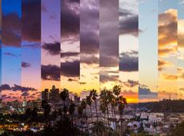

Part B : Summative Option for Photo Animation
If you enjoyed creating the short time lapse (stop motion) for Part A, you can scale the project up into a summative project. Summative options for a photo animation project include:
- Exploring other photo animation techniques such as Cinemagraphs, GIFs, and 2D Parallax.
- Or making your Part A animation longer.

Research & Planning
- Perform a Google search for “Time Lapse Photography”, “Stop Motion Animation”, and “Photo Animation”.
- Create a Photo Animation Research Presentation in Google Slides.
- Your Photo Animation Research should contain the following information:
○ 2-5 links to web content you found useful for design and technical ideas.
○ 2-5 YouTube animation tutorials that helped you figure out some animation techniques.
○ Write a brief description about the content as part of your research.
○ 2 Photo Animation examples that you found inspiring.
○ Direct connections between your examples (influences) and your project should be made.

Guidelines
- Create a 30-60 second (or longer) demo reel style video of your photo animations.
- You may also choose to create a stop motion animation with a story (narrative development).
- Your video should include an intro title.
- Make sure your video also has music.
- The end of the video should include credits for music and any stock images you may have used.
- You photo animations will be evaluated on the following criteria:
  - Image Quality: focused images, no flicker or light variations, framing (composition, layout), use of photoshop for photo editing skills.
  - Creativity: interesting effects, entertaining for the audience, good story development, ideas are clearly expressed.

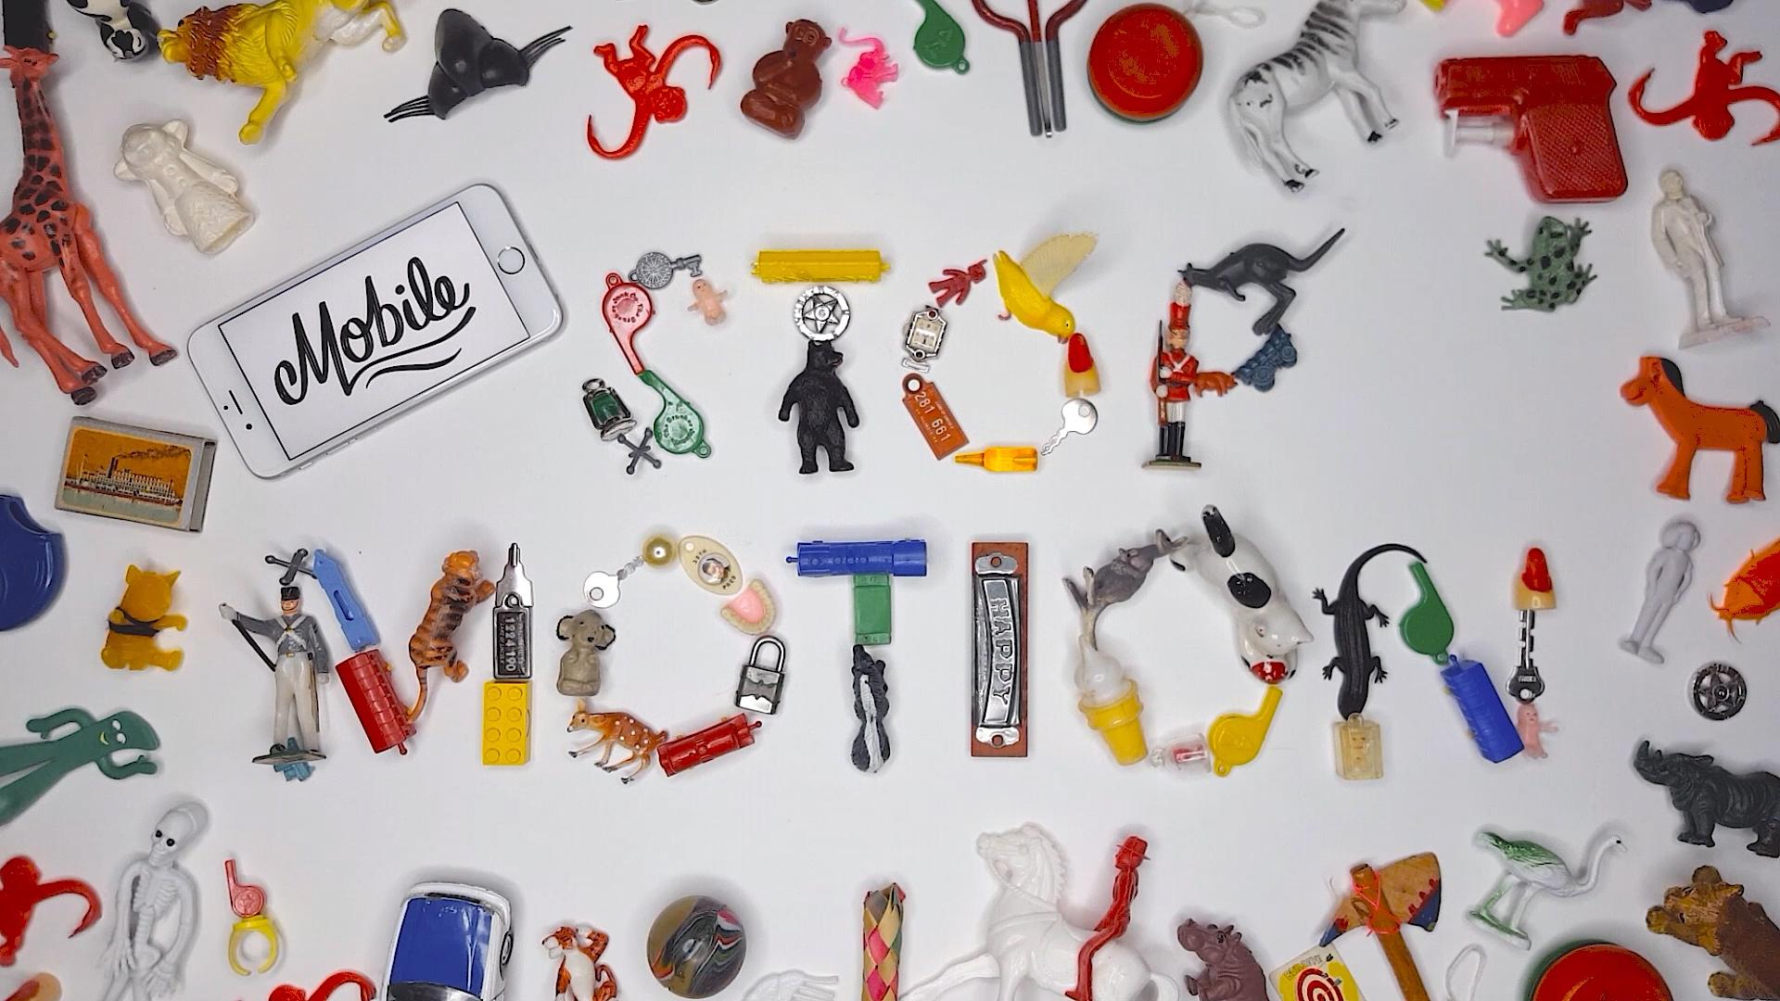 |  | 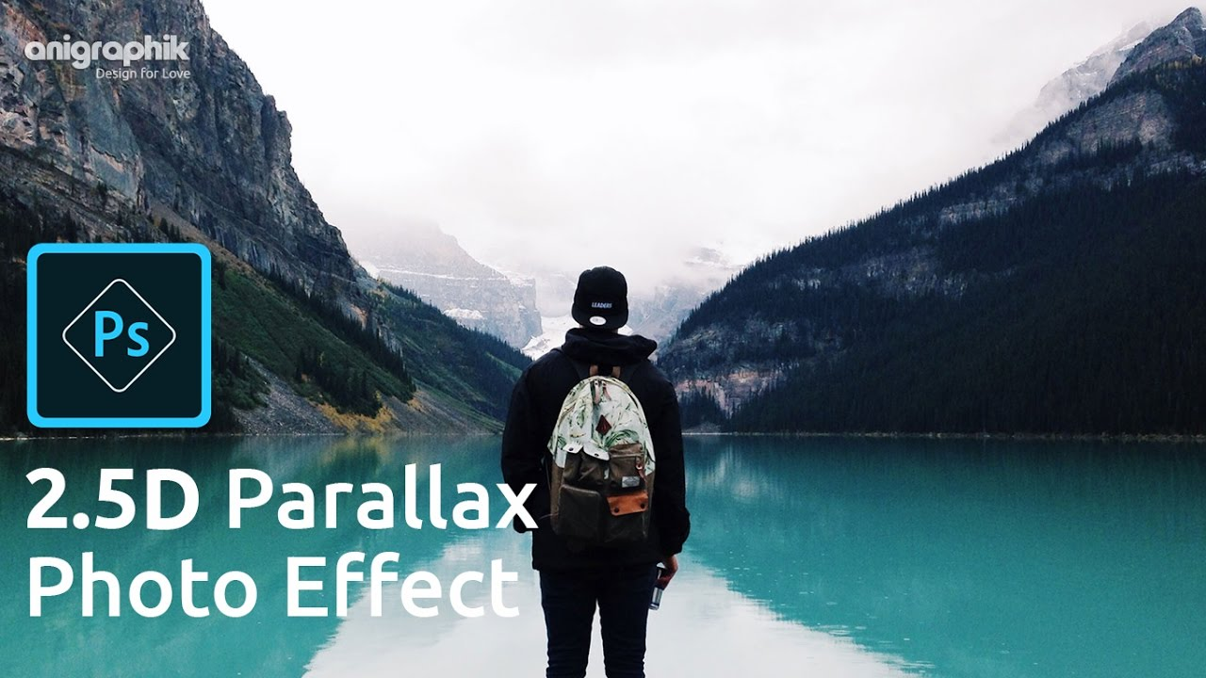

Photo Animation Evaluation

Description | Comments | Levels
Part A : Short Time Lapse and / or Stop Motion

The 20-30 second animation shows a good use of camera techniques:  - Images are focused and not blurry  - Lighting is consistent and does not flicker  - Photo editing skills are evident. |  | 0-1-2-3-4
The project demonstrates an understanding of framing & composition. Basic layout and design rules of photography have been used. |  | 0-1-2-3-4
Music has been used to enhance the viewing experience. |  | 0-1-2-3-4
Part A: Overall Mark |  | %
Part B: Summative Option | Studio Work - Application of Skills

The 30-60 second animation effectively uses an intro title and music. |  | 0-1-2-3-4-
Image Quality: focused images, no flicker or light variations, framing (composition, layout), use of photoshop for photo editing skills. |  | 0-1-2-3-4
Creativity: interesting effects, entertaining for the audience, good story development, ideas are clearly expressed. |  | 0-1-2-3-4
Part B: Summative Option | Research Presentation
Effective research has been demonstrated for 2-5 links and tutorials in your Google Slides Presentation. |  | 0-1-2-3-4
Direct connections have been provided between your research (influences) and your project. You have clearly explained how your research was useful in your learning of photo animation techniques. |  | 0-1-2-3-4
Part B: Summative Overall Mark |  | %

