Themed Photo Calendar | Guidelines
________________________________________________________________________________________________________________________________________________________________
Part A : Birth Month Calendar Page  Create a Template Theme  - For this assignment, you will create a photographic image and a calendar theme for your birth month using Photoshop.  - Remember composition and layout rules.  - Focus on the elements and principles of design.  - Choose fonts and colours that work with your image and the season of your birthday. |  | 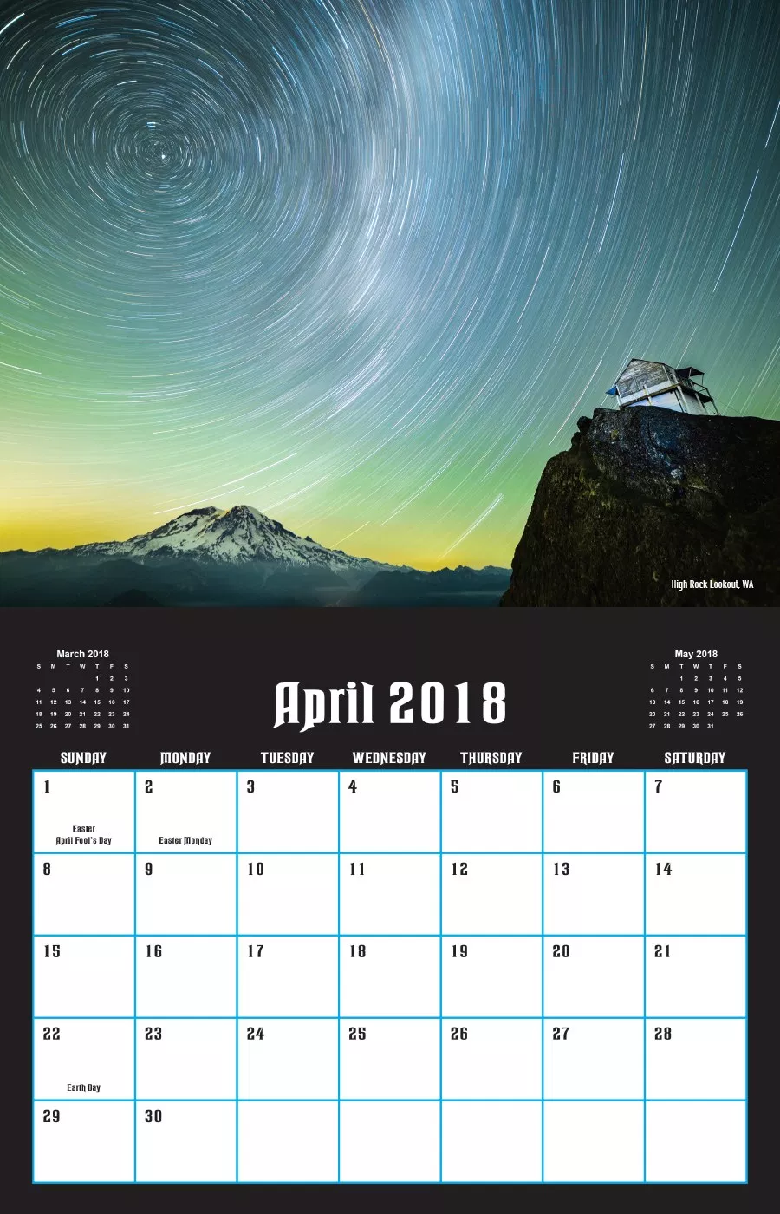
Part B : Summative Option for a 12 Month Calendar
If you enjoyed creating the calendar page for Part A, you can scale the project up into a summative project with 12 pages and photographic images.
- Capture 12 photos based on a common theme that will be used to create a 12-month calendar using Photoshop.
- Choose a theme (topic or subject) that you can use to help organize the photos for your calendar.
- You will capture 12 unique photographs that you will use for the 12 months of the year in the calendar.
- You will have to make each calendar page separately. Start with the month of January. Open a new file in Photoshop and make sure the settings are at minimum 8 ½ “ x 11” and that the resolution is 300 pixels per inch.
- Create the text / squares for your calendar by using the grid in Photoshop as a guide.
  - > View > Show > Grid
  - Then use your line and text tools to draw. Reference another calendar for the correct numbers.
- When your pages are done, save the Photoshop files as jpeg files and upload to Google Classroom.
- It’s recommended to use a DLSR camera for print quality images.

Final Design Skills & Appearance
- Review cropping, composition and layout skills such as foreground, middleground, and background object placement.
- Rule of thirds and triangular compositions are classic ways of composing an image.
- Pay attention to line, shape, color, form, and texture in your photos.
- Make sure your images use adjustments such as levels, hue saturation, and photo filter.

Start Theme Ideas  - Animals  - Sports  - Nature  - Video Games  - Family  - Music  - Cars  - Cosplay | 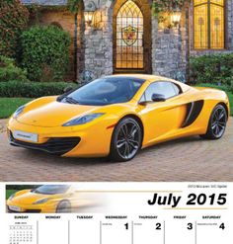 | 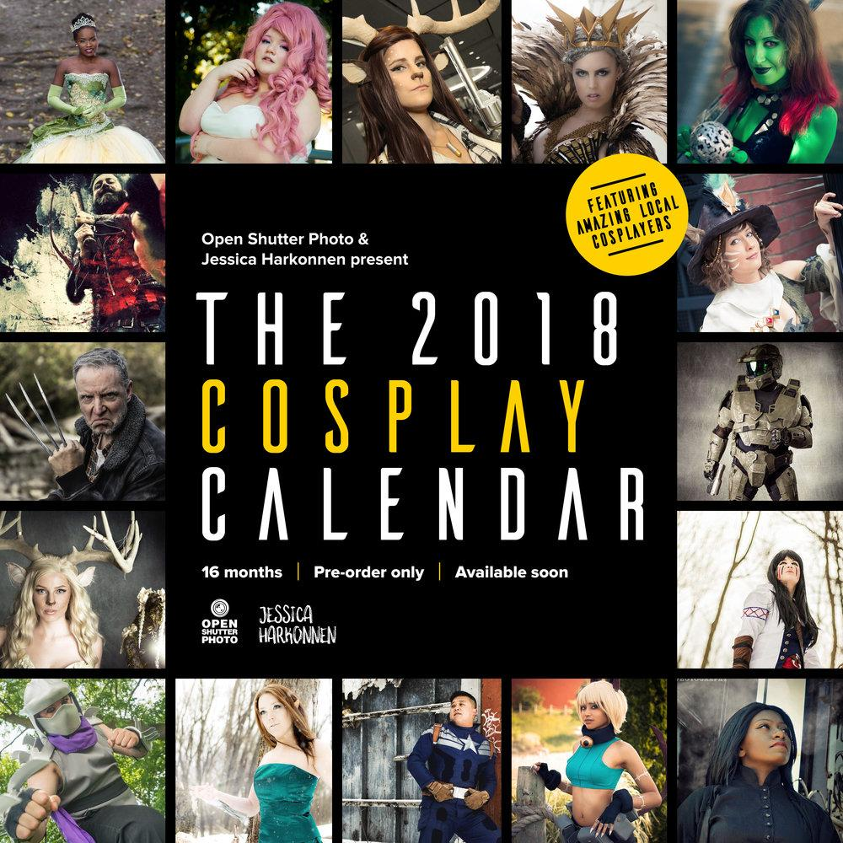 | 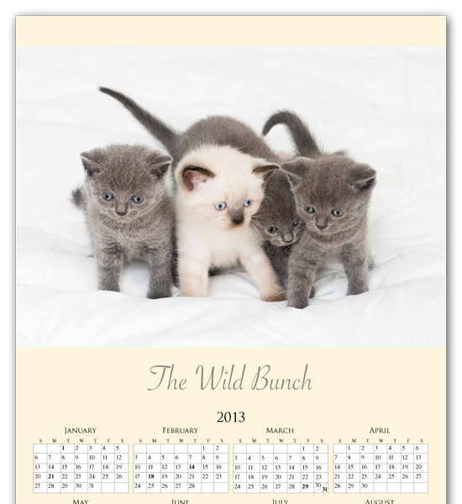

Narrative Calendar Evaluation

Description | Comments | Levels
Photo Composition - Exploration | Process

The photo or 12 photos show a strong range of compositional and photographic techniques. You have used a variety of angles and lighting to compose your images. |  | 0-1-2-3-4
Each photograph displays an effective understanding of composition e.g. the rule of the thirds. |  | 0-1-2-3-4
Editing and Techniques | Studio Work - Application of Skills

The image or 12 images have been enhanced with editing to have a polished and professional look. The images are ready for print. |  | 0-1-2-3-4
Calendar - Layout, Composition, Clarity | Studio Work - Application of Skills

The design of your calendar demonstrates a strong understanding of composition and layout such as placement of objects and colour. |  | 0-1-2-3-4-
The background and font choice of your design enhances the photographic image. The placement of text and font choice is clear for the audience to read. |  | 0-1-2-3-4
All 12 photos suit the theme of the calendar, and the overall appearance of your calendar is cohesive with that theme. |  | 0-1-2-3-4
Exploration | Experimentation | Effort – Sharing Work & Ideas (Critical Analysis)
Planning & Process (Ideation)  The project displays thoughtful planning.  There is evidence of trial and error in the formation of the final concept. |  | 0-1-2-3-4
Critical Analysis  Sharing of the work provides insight into the creative process.  Displays strength in ideas, techniques and an interest in continual refinement of skills. |  | 0-1-2-3-4
Overall Mark |  | %

