Product Photography and Still Life Photography

Product Photography - Basic Functions
- It is eye catching and makes them want to buy or click on your product.
- It is clear and communicates important information about the product.
- It has purpose, emotional connection and stylization that represents your brand.
- It helps consumers visualize what it would be like to own and/or use the product in their personal lives.

5 Types of Product Photos
- Different photo styles can convey a variety of information about your product.
- By using different photo types in an ecommerce storefront, you can give shoppers a well-rounded understanding of your product.

1. Studio  These are shots of your product on a plain background with plenty of light to highlight and give your customers an easy glimpse of your product. Studio shots are a bright, clean and simple way to show potential customers what you’re selling. | 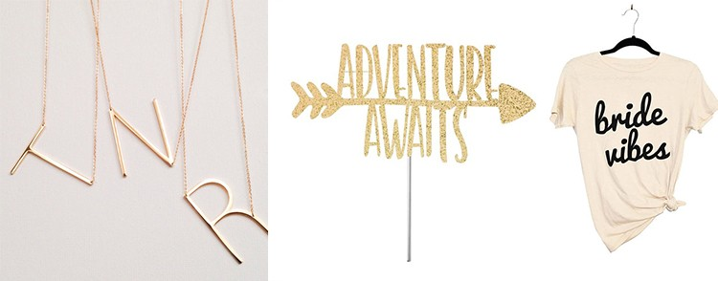
2. Lifestyle  Lifestyle shots are the photos that help inspire your customers to purchase and make them feel like they “need” to have the product in their own personal lives. These photos showcase your products in a setting and display how they are intended to be used/look. | 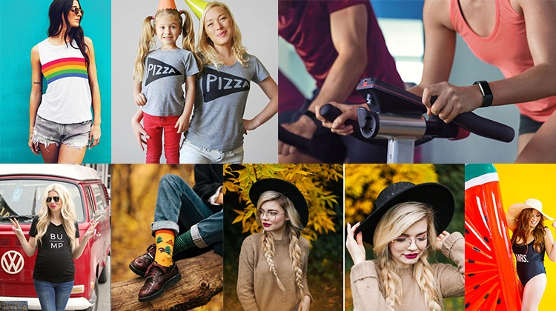
3. Scale & Details
A scale photo of your product is one that visually communicates the size of your products.
Since customers cannot pick up and physically see your items like they would in a brick and mortar shop, photos like this reassure your shoppers that the product will be what they expected.
4. Group
Group shots are especially good for documenting products sold in multiples, such as sets of custom shirts, cookware, sets of bowls or silverware, etc. You can also use group product photography to show the variation of different colors, finishes or materials you offer for purchase
5. Authenticity & Quality  People crave “behind the scenes” and “process” product photography and content. We live in a world where people question a lot, so creating a sense of authenticity through your product photography is always a good idea. | 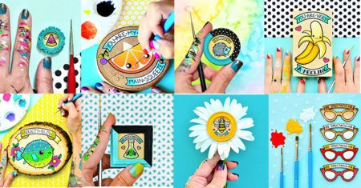
Resource: Oh Snap! The Ultimate Product Photography Guide - Disruptive Advertising

Still Life - Basic Ideas
- Lighting and visual appeal  - Keeping objects in focus (not blurry)  - Photo editing skills | Resources:  Tips for Getting Started with Still Life Photography  35 Superb Examples of Still Life Photography

Still Life Photography - 5 Things to Keep in Mind
1. Lighting  You don’t need anything fancy to light a still life. Natural light from a window will do the trick. A lamp, light painting with a torch, or a makeshift softbox are great fun to experiment with.  If you’re relying on natural light, figure out the best time for a shoot or wait until the light has improved. When using a flash, you should consider diffusing the light, using an external flash and directing the light with a reflector. | 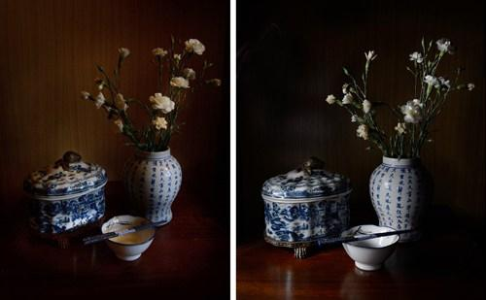
2. Composition  Good composition skills go a long way with still life, and is as important as good lighting. Understanding things like the rule of thirds can be very helpful, even if you choose to then ignore it.  With still life photography, if you just keep moving your arrangement around, you will find one that works. Don’t just settle on the first one you set up. | 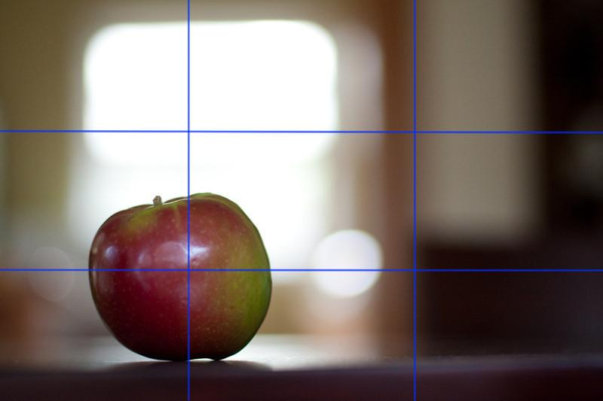
3. Background
You want to make sure that the background works well with your main subject. For example, think about how the background will look in-focus and out-of-focus. Maybe you can find a background with an interesting texture or no texture at all. A single-color background can be an effective way to make your subject stand out.

Foreground is another thing to think about while arranging the background. How will you draw the eye into the composition?
4. Tripods  - Make sure you use one.  - Keep objects in focus.  - Play with depth of field.  - Don’t forget to move the tripod around the still life.  - Get shots from multiple angles  - Experiment with lighting.  - Try different exposures. | 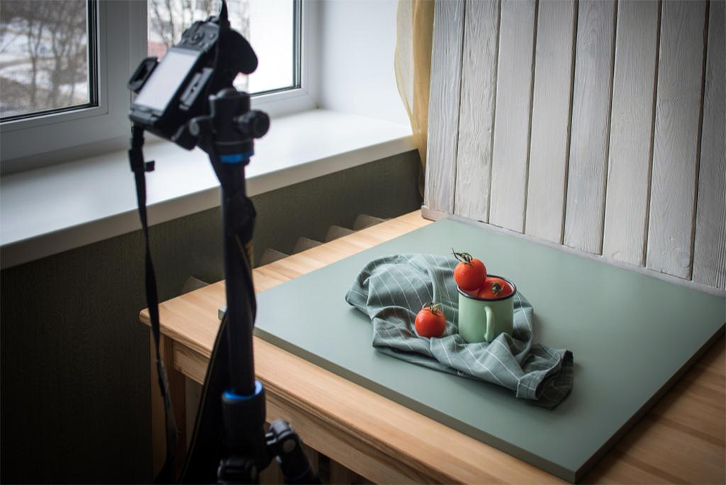
5. Elements and Principles of Design  - Balance  - Rhythm/ Repetition  - Contrast  - Texture  - Pattern  - Emphasis  - Overlapping Shapes  - Focal Point | 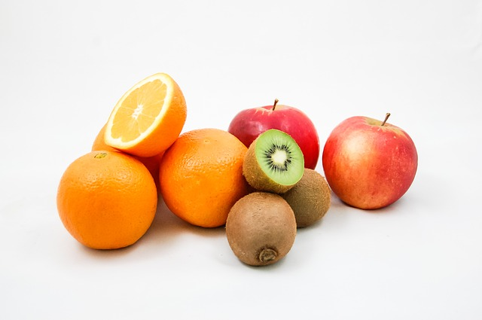

Product Photography and Still Life Photography - Evaluation
Guidelines  - Create 3 still life images  - Produce 3 product photos  - Take shots in full-auto, semi-auto, and manual  - Adjust exposure (shutter speed, aperture size, ISO) | Camera Techniques  - Depth of Field (Small & Large)  - High & Low Angle Shots  - Mid Length Shot  - Close up Shot

Description | Comments | Levels
Studio Work - Application of Skills
The elements and principles have been effectively used in the arrangement of your images. |  | 0-1-2-3-4-
Camera techniques have been used to explore lighting, camera functions, DoF, and various angles. |  | 0-1-2-3-4-
Your photos display a strong understanding of composition through background setup, placement of objects, and lighting. |  | 0-1-2-3-4-
The photos create visual interest through the use of groupings, scale & detail, and lifestyle compositions. |  | 0-1-2-3-4-
Each of the photos are in-focus and display proper exposure (lighting). |  | 0-1-2-3-4-
The final presentation of your images displays a strong compositional sense, and an effective overall appearance. |  | 0-1-2-3-4-
Exploration | Experimentation | Effort – Sharing Work & Ideas (Critical Analysis)
Planning & Process (Ideation)  The project displays thoughtful planning.  There is evidence of trial and error in the formation of the final concept.  - How did you start your project?  - Did you use any planning or brainstorming strategies?  - How did you organize your media content? |  | 0-1-2-3-4-
Critical Analysis  Sharing of the work provides insight into the creative process.  Displays strength in ideas, techniques and an interest in continual refinement of skills.  - What did you do well?  - What challenges did you encounter?  - Where did you find inspiration? |  | 0-1-2-3-4-
Overall Mark |  | %

