Photography- Variations Grid
- Landscape, Architecture, and Open Theme Photographs
- 3 Four Section Grids

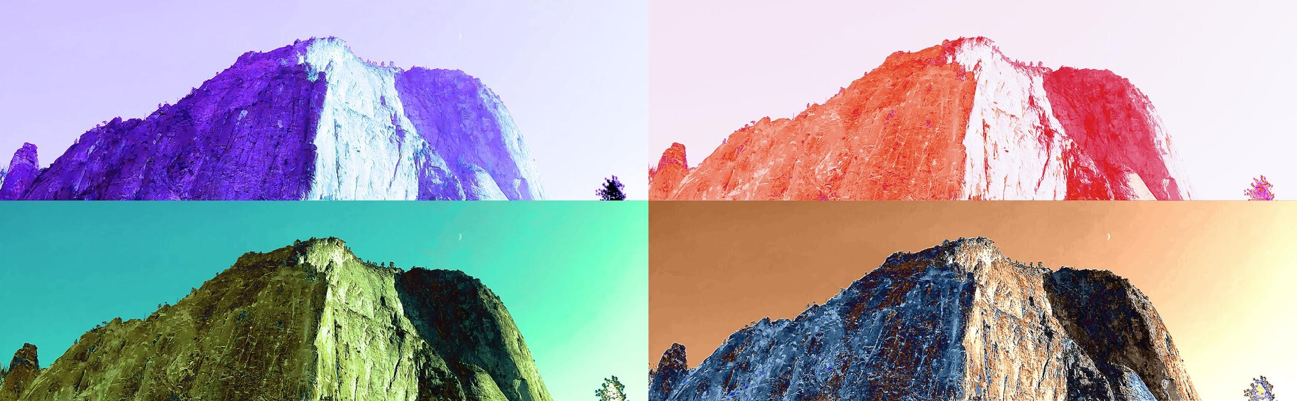 | 3X

- In this assignment you will create 3 four sections grids with different photographs for each grid.
- The first grid will be a landscape image, the second grid will be an architectural photograph, and the third grid will be an open theme of your choice.

Part 1 - Collect Photos & Inspiration
- Capture as many landscape or architectural photographs that you can. Then choose your best images to use for Part 2- Creating a Variation Grid in Photoshop.
- Please read the following information on famous photographers and browse through their work to gain inspiration:

Landscape Photography
Landscape photography is a very special type of photography. This type of photography focuses solely on the beauty of nature itself. There are usually no human beings in any of these photographs unless they are part of the landscape. Just this simple fact alone is what makes landscape photography truly unique. Among the great landscape photographers is Ansel Adams. He was born on February 20, 1902 in San Francisco, California as an only child and was named after his uncle Ansel Easton. Along with being a photographer he was also an environmentalist. His specialty was the black and white photograph. One of his many
accomplishments included inventing the zone system. He also co-founded a group of photographers with Edward Weston called Group f/64. This stood for a very small aperture setting on a large format camera.

- The work of Ansel Easton Adams (1902 – 1984)

Architectural Photography
Julius Shulman was one of the pioneers of the Architectural Photograph movement. The brilliance of buildings like those by Charles Eames, as well as those of his close friend, Richard Neutra, was first brought to light by Shulman’s photography. The clarity of his work demanded that architectural photography had to be considered as an independent art form. Each Shulmanimage unites perception and understanding for the buildings and their place in the landscape. The precise compositions reveal not just the architectural ideas behind a building’s surface, but also the visions and hopes of an entire age. A sense of humanity is always present in his work, even when the human figure is absent from the actual photographs.

- The work of Julius Shulman (1910 – 2009 )

Part 2 - Photoshop Skills
>Image >Canvas Size  >Adjustments (Levels, Hue Saturation.…) | >Adjustment Layers (inside layers pallet)  - Masks & Non-destructive Editing  - Photo Filter (tinting)  - Gradient Mapping (with Soft Light Blending Mode)
>Edit >Transform (Scale, Rotate, Skew, Warp….)  - Ctrl+T (shortcut key) | - Blending Modes (Multiply, Soft Light)  - Layer Opacity  - Adding a Mask to a Layer  - Layer Organization - Naming  - Layer Organization - Groups & Masking
>Filter >Filter Gallery  >Blur Gallery (Gaussian Blur, Motion Blur, Tilt Shift….) | >Window >Actions  - Record what you’ve done to an image and auto repeat it on other ones.

Part 2 - Instructions | Variation Grid - Open Theme Suggestions
- Make a variety of adjustments to each image according to new and reviewed skills listed above (think of a patterned quilt).  - You may try overlapping the images to create a unique blending with the photos.  - Submit all 3 grid designs when complete. | - Humans of Kitchener  - Landscapes (sunsets, beach scenes, trees)  - An object from different viewpoints  - Video game pose / satellite photo  - Toy structure  - Food item  - Things to do with a deck of cards  - Balloons & bubbles

Grid Variations Mark Sheet
 | Process  - The project follows basic required format:  - 3 sets of grids with 4 photos in each  - The photography work experiments with varied image adjustments. | Communication & Creativity  - Project shows the ability to use digital technology- cameras and workflow in an effective manner.  - The project communicates both effort and creativity through the use of layers, filters, and blending. | Final Product  - Displays application of skills in composition, layout, and use of software.  - Demonstrates a strong understanding of the elements & principles of design (e.g. colour, texture, contrast, unity).
Grid 1  Landscape | -1-2-3-4- | -1-2-3-4- | -1-2-3-4-
Grid 2  Architecture | -1-2-3-4- | -1-2-3-4- | -1-2-3-4-
Grid 2  Open Theme | -1-2-3-4- | -1-2-3-4- | -1-2-3-4-
Over all Mark: %

